Scala programming

Name – chaithanya gowda l

Write a Scala program that creates a class called Person with properties like name, age and country. Implement methods to get and set properties.

INPUT:

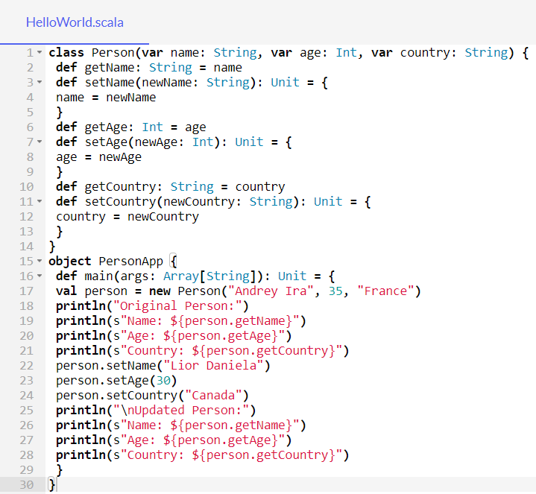

OUTPUT:

